Exercise 10
1.Display the sum of ages of employees working at BIgnet.
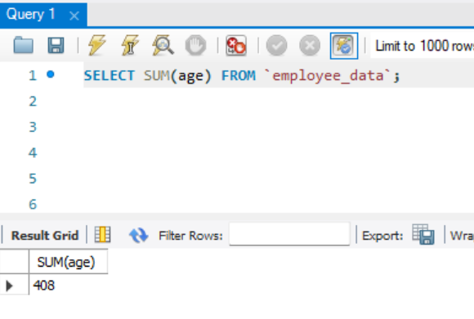
2. How would you calculate the total of years of service the employees of Bignet have in the company?
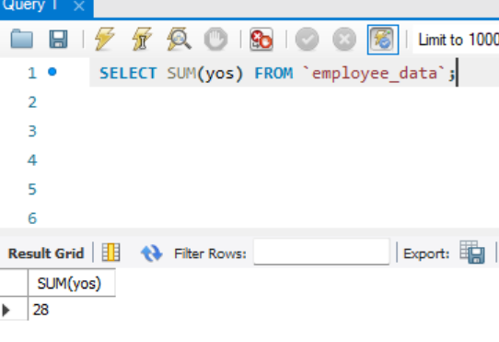
3. Calculatr the sum of salaries and the average age of employees who hold “Programmer” title.
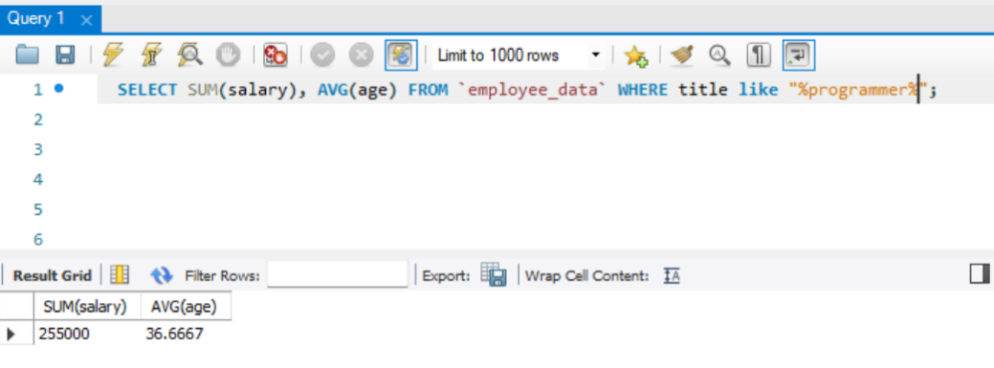
4. What do you understand from the following statement?
Select (SUM(perks) / Sum(salary) * 100) from employee_data;

It gives the total perks as a percentage of the total salary related to all employees.

